* Encryption setting are in storage accounts.
* They are encrypted by default.
* 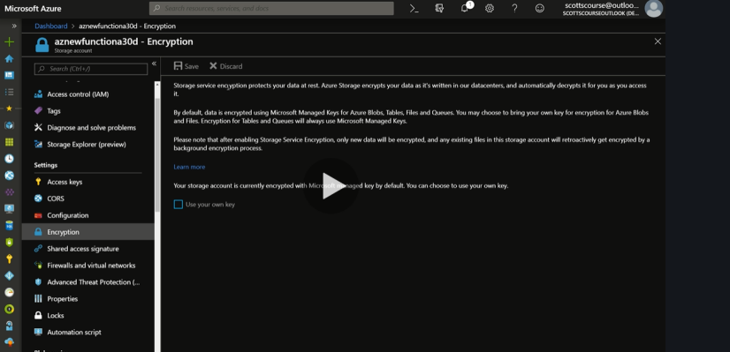
* We can opt out to manage our own keys for that.
* It will be stored in the key vault.
* We can enable Secure Storage from Configuration tab of Storage Accounts.

Data Encryption and SL Databases

* Data encryption in SL Database.
* 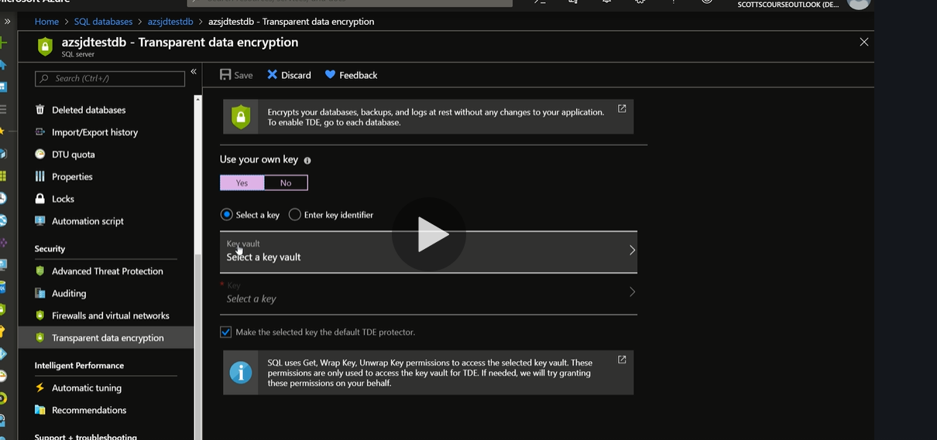
* Again Microsoft does it for you but we also have an option for “Use your own Key”
* Transparent Encryption is for SQL Servers and SQL Databases.